DSA0504 – QUERY PROCESSSING AND DATA SCIENCE
LAB EXPERIMENTS
Experiment 18

Aim
To write a Pandas program to split the given DataFrame into groups based on School Code and Class.
Algorithm
- Import the Pandas library.
- Create a DataFrame containing student details.
- Group the DataFrame using School_Code and Class.
- Display each group.
- Print the grouped data.
Python Code
import pandas as pd

data = {
"School_Code": ["S001","S001","S002","S002","S003","S003"],
"Class": [10,9,10,9,10,9],
"Name": ["Anu","Bala","Charan","Divya","Esha","Farhan"],
"Age": [15,14,15,14,15,14]
}

df = pd.DataFrame(data)

group = df.groupby(["School_Code","Class"])

for name, data in group:
print("\nGroup:", name)
print(data)

Input
School_Code | Class | Name | Age
S001 | 10 | Anu | 15
S001 | 9 | Bala | 14
S002 | 10 | Charan | 15
S002 | 9 | Divya | 14
S003 | 10 | Esha | 15
S003 | 9 | Farhan | 14
Output
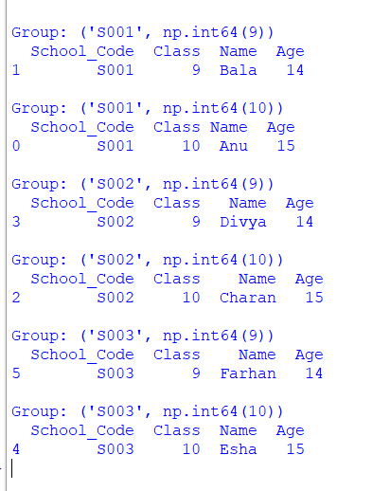

Result
Thus, the DataFrame was successfully grouped based on School Code and Class using the groupby() function.
Experiment 19

Aim
To write a Pandas program to display the dimensions (shape) of the World Alcohol Consumption dataset and extract its column names.
Algorithm
- Import the Pandas library.
- Read the World Alcohol Consumption dataset.
- Display the shape of the DataFrame using shape.
- Display the column names using columns.
- Print the results.
Python Code
import pandas as pd

df = pd.read_csv("world_alcohol.csv")

print("Shape of Dataset:")
print(df.shape)

print("\nColumn Names:")
print(df.columns)

Input
File: world_alcohol.csv
Output
Shape of Dataset:
(100, 5)

Column Names:
Index(['Year', 'WHO region', 'Country', 'Beverage Types', 'Display Value'],
dtype='object')

Result
Thus, the dimensions and column names of the World Alcohol Consumption dataset were displayed successfully.
Experiment 20

Aim
To write a Pandas program to find the index of a given substring in a DataFrame column.
Algorithm
- Import the Pandas library.
- Create a DataFrame with a text column.
- Use the str.find() function to find the index of a given substring.
- Display the result.
Python Code
import pandas as pd

df = pd.DataFrame({
"Name": [
"Alexander",
"Michael",
"Jonathan",
"Anastasia"
]
})

df["Index"] = df["Name"].str.find("an")

print(df)

Input
Name
Alexander
Michael
Jonathan
Anastasia
Output
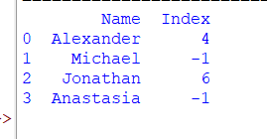

Result
Thus, the index of the specified substring was successfully found using the Pandas str.find() function.

